1. Alex and Alan bought n different products from Allmart. Write a C program to calculate separate bill for them, by passing prices of product to functions using variable length arguments.

Code

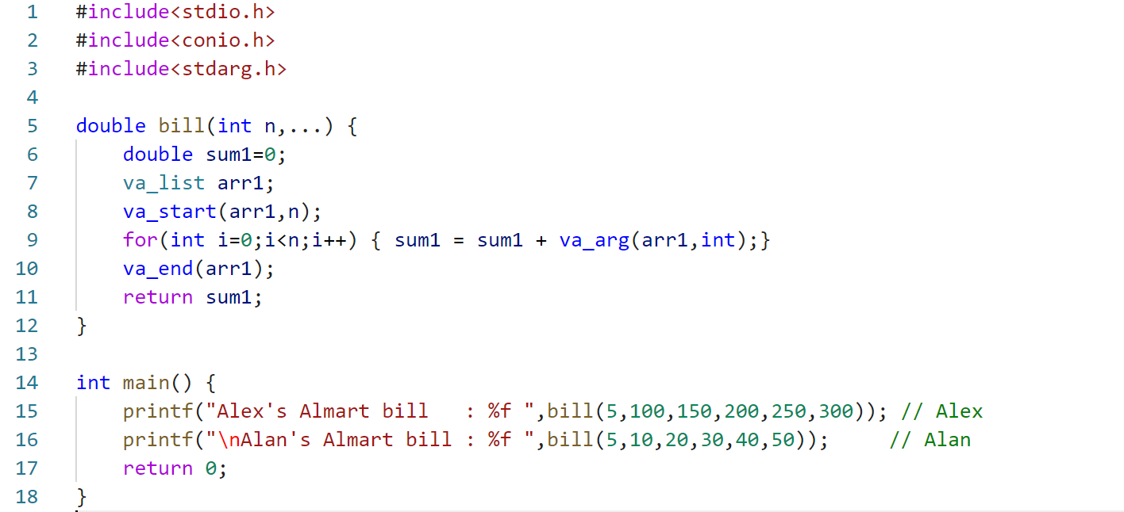

Output

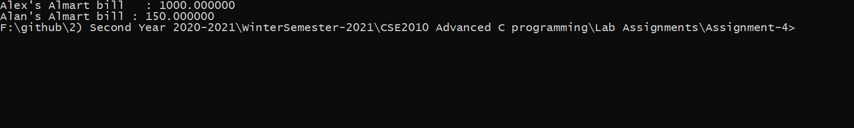

2. Write a C program to display the grade of n students by calculating the average of 3 marks using bit fields.

Code

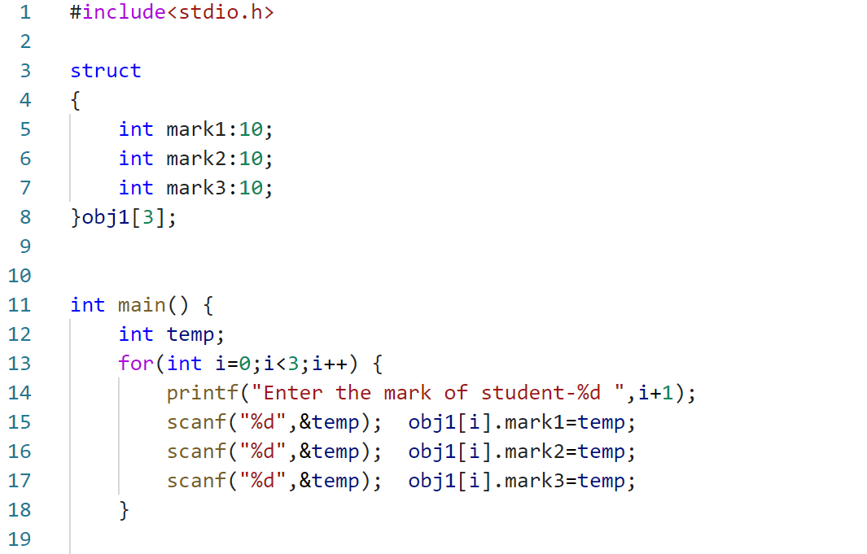  
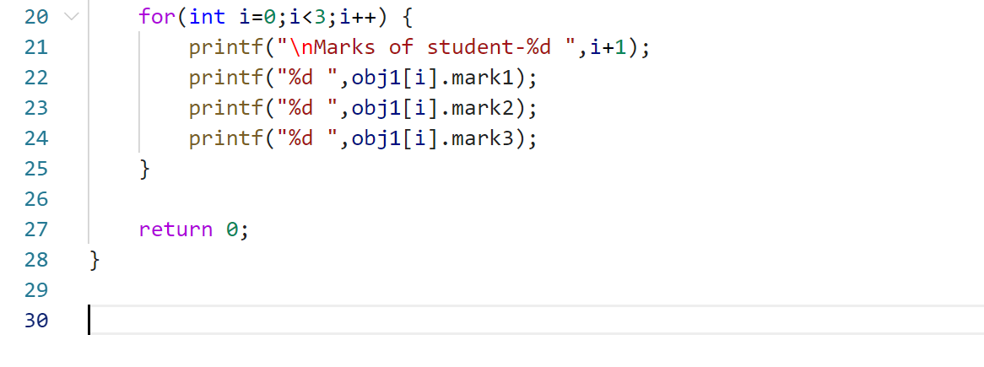

Output

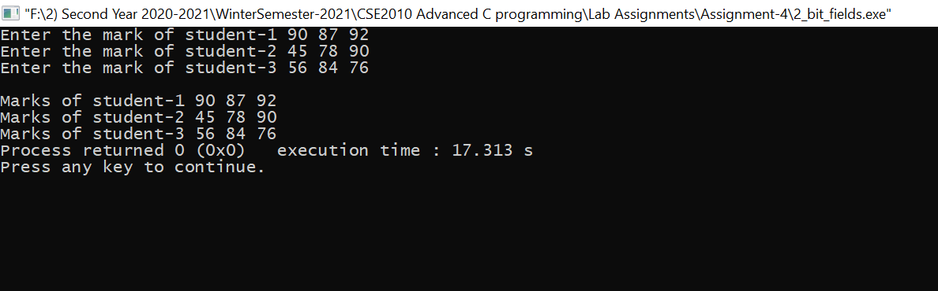

3. Write a C program to create an array A of n numbers. Create another array B with the square of elements of array A, by using passing and returning array as pointers to function.

Code

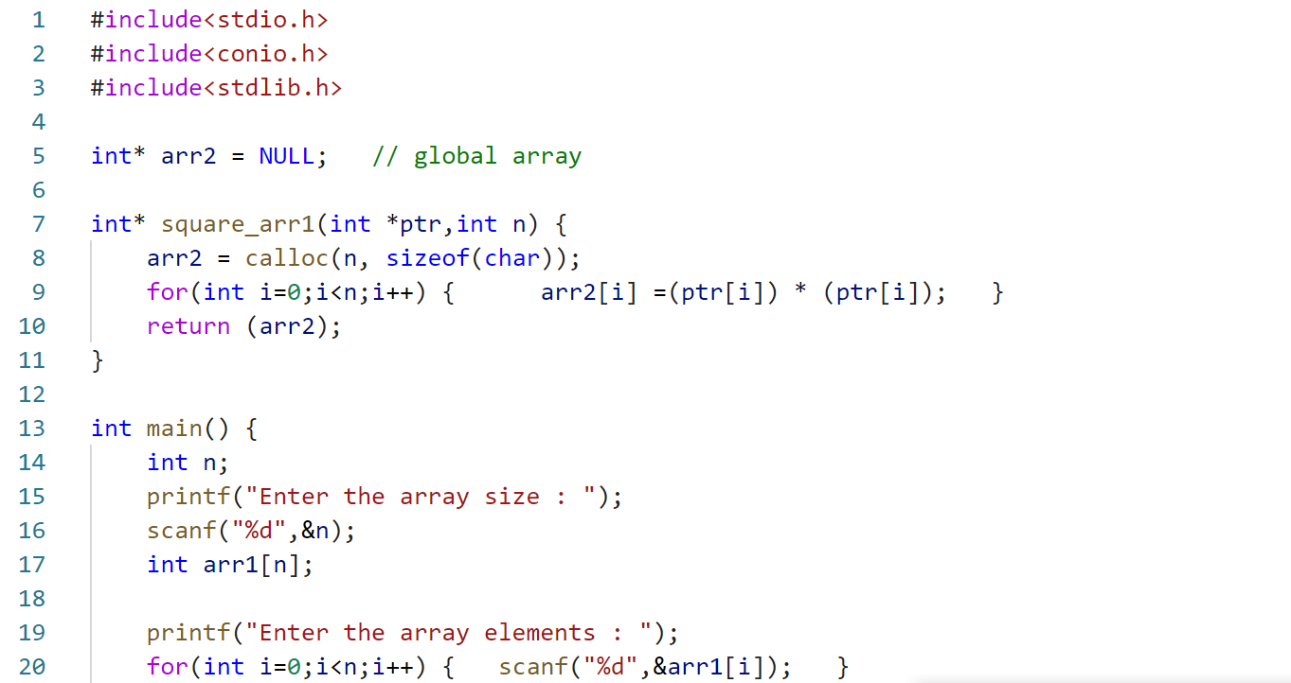  
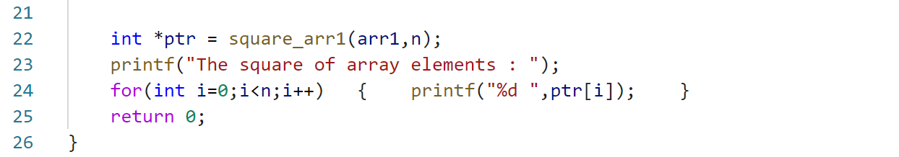

Output

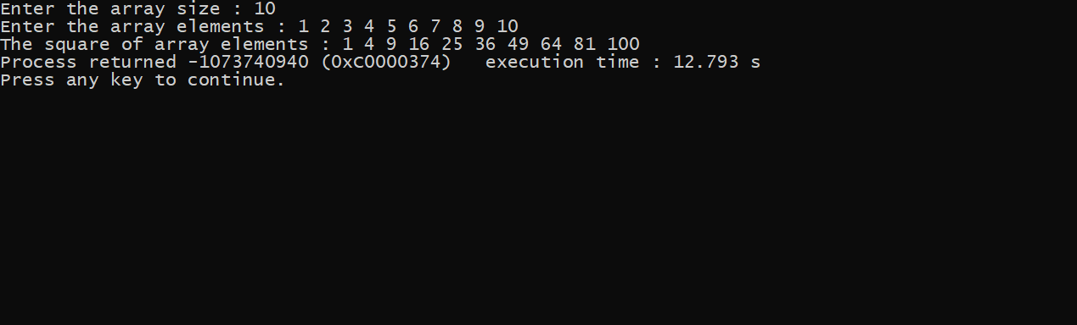

4. Write a C program to find whether a given number is prime or not using function pointer.

Code

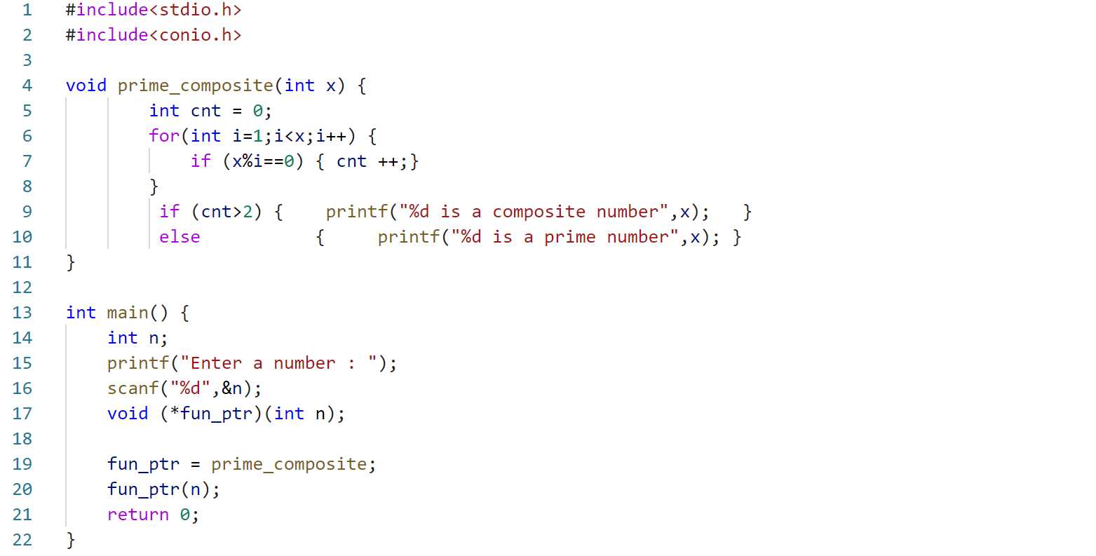

Output

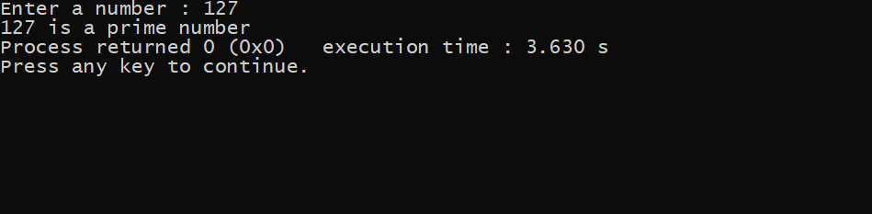

5. Write a C program to create a file F1 with a string1. Create another file F2 from F1 such that all the characters of string1 as upper case and print the result in screen. While creating the files check for the validity of file creation.

Code

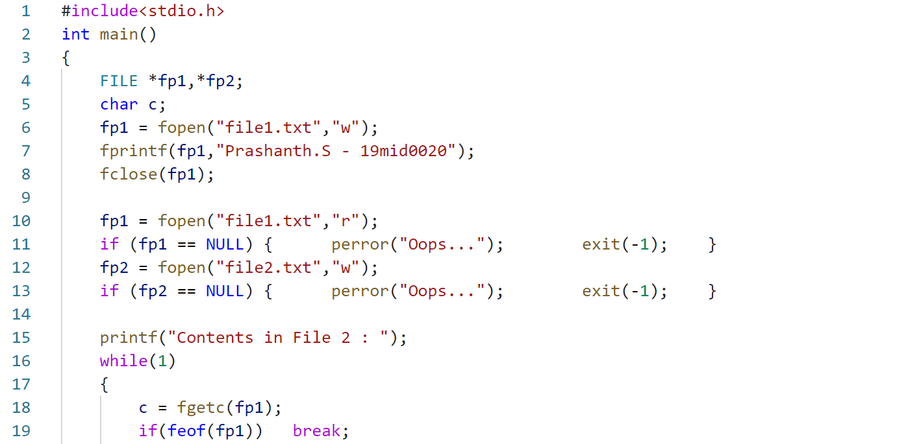  
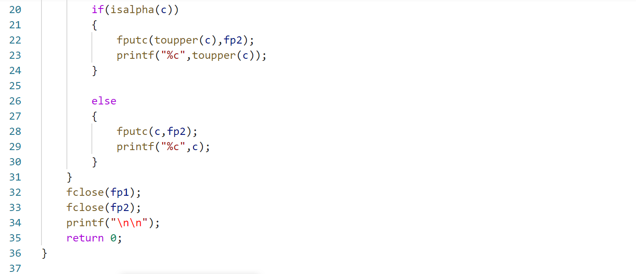

Output

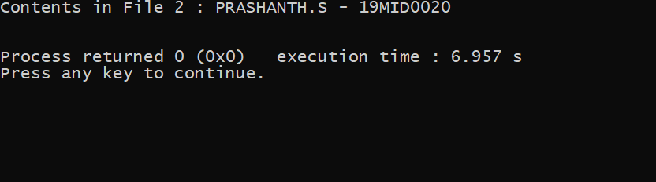

6. Write a C program to create a   
student record with **name, id** and **date of birth** and store it as a binary file. Later append another record of student to the same file.

Code

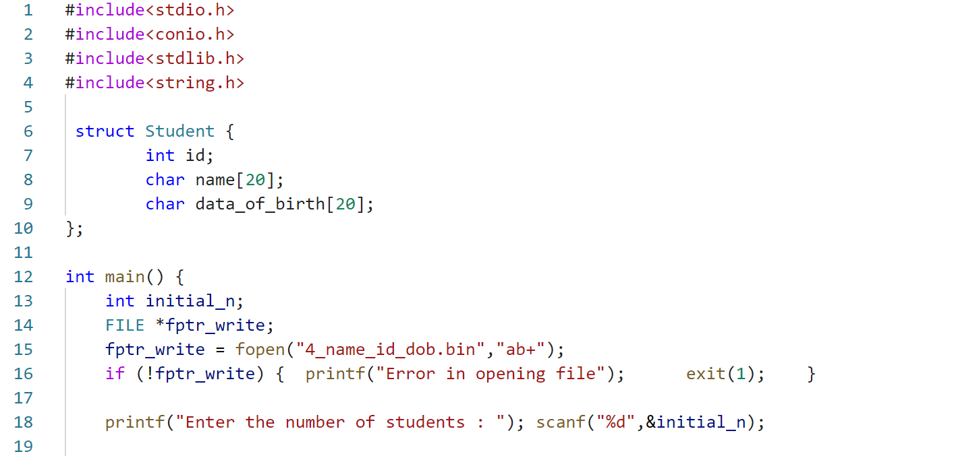  
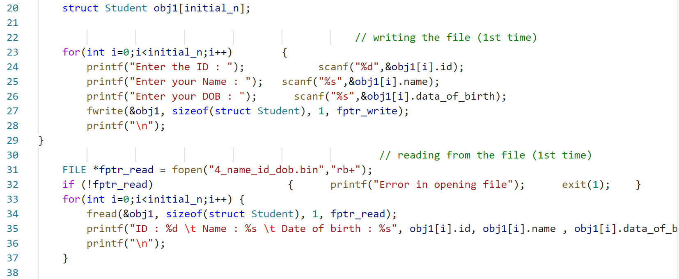  
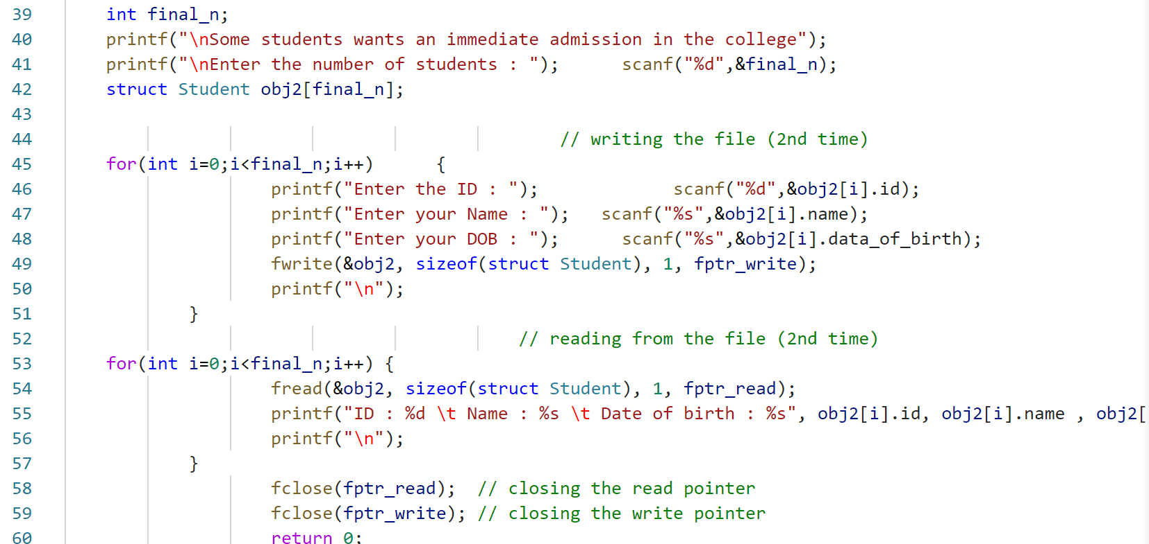

Output

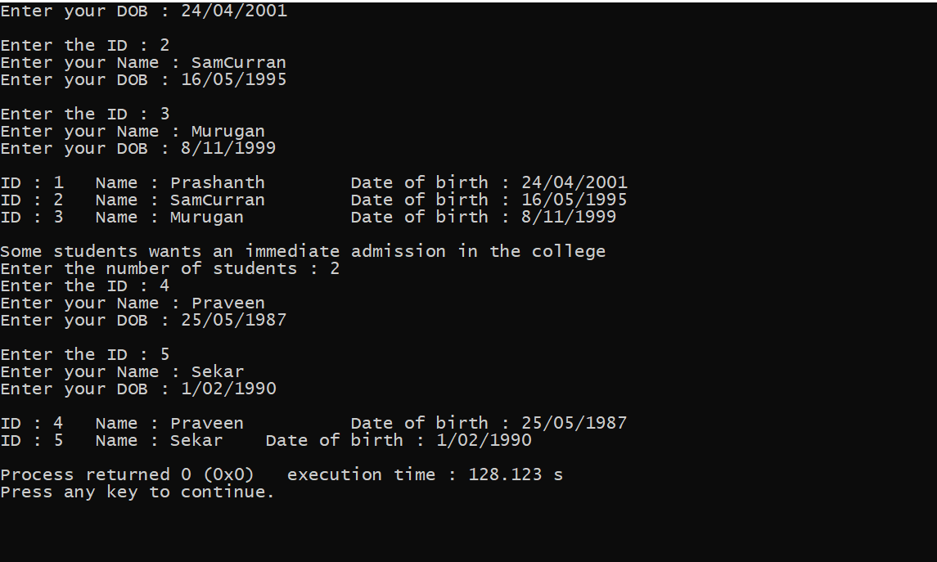

7. Write a C program to find the sum of 5 numbers using nested macro.

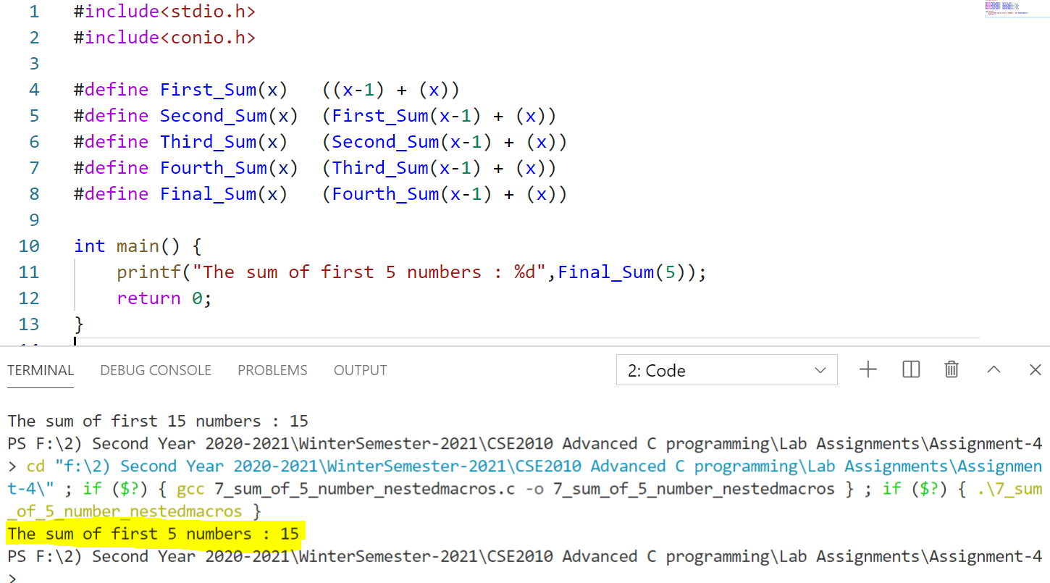

8. Just for learning: Write a C program to call main() function recursively and perform sum of 1 to 10 numbers.

Code

